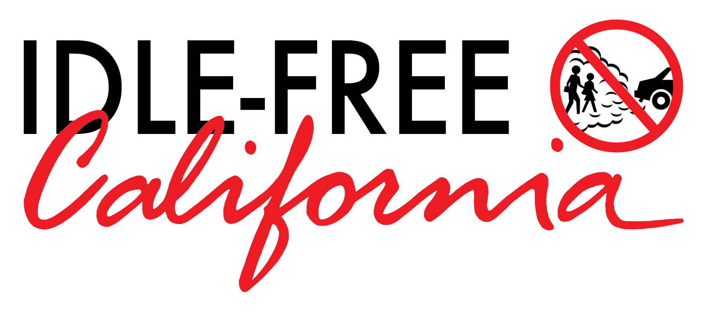

Script for Driver Contact Event

Idling motorists at school are approached over two days to ensure that many of the drivers are reached and asked to participate in reducing idling. The suggested script that is used to approach them is as follows (try to memorize – too much reading makes it less likely to persuade your audience):

Hi, my name is ____________ and I am a student here participating in a project to reduce vehicle idling. Would you have a minute for me to share some information on the benefits of reducing engine idling - a way to help the environment, improve health and save money, too?

IF NO -- thank and discontinue.

IF YES -- continue. . .

[Proceed through the script while holding the information sheet in hand – this gives a reminder of the issues to talk about -- saving money, breathing easier, the environment -- and makes it easier to offer them the sheet when you're done, making the conversation faster]

When you don't idle your engine, it reduces the amount of gas being used. This means you'll save money on fuel – $60 to more than $200 per year, depending on an engine size. In addition, you and others around the vehicle won't have to breathe in fumes from a vehicle that is going nowhere. Not idling will also cut carbon emissions that contribute to climate change, and conserve energy. And the U.S. Dept. of Energy tells us starters in today’s vehicles are very durable and do not suffer damage from turning the engine on and off up to 10 times a day.

We have these great information sheets that explain these benefits. Would you like one?

We're also asking people to make a commitment to turn off their engines when they're waiting in their vehicles by placing this window cling decal in their windows. It is a reminder to turn your engine off, and also tells others of your commitment to reduce idling. It gets placed on the inside of the car window and can be easily removed at a later time. Many people have already made this commitment. Would you also be willing to do so by placing this sticker on your window?

Thank you and have a nice day.

