Idle Free Schools
Turn Your Key, Be Idle Free!

Sample School Newsletter Article

[Insert Name of School] is supporting an idling reduction campaign here at the school to reduce student’s exposure to air toxics that are emitted from idling vehicles. Also, if everyone in the U.S. stopped idling for five minutes a day it would be equivalent to taking five hundred thousand cars off the road and saving 1.6 million tons of CO₂!
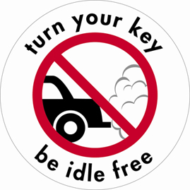
We are asking parents/guardians to sign pledge forms that they won’t idle unnecessarily. All teachers, staff, and delivery truck drivers will also be asked not to idle unnecessarily. You will see new idling signs posted outside the school and there will be an idling driver contact event sometime soon to remind parents not to idle when waiting to pick up their kids after school.

Save money and protect the air by turning off your car when waiting more than 10 seconds.

Turn Your Key, Be Idle Free!

[Schools are asked to place similar language on school website]

